WE NEED YOUR HELP WITH OUR EASTERN GATEWAY RESTORATION PROJECT

Dear Mr. Thurmond,

My name is (insert your name here) and I am a registered DeKalb County voter who lives at (insert your address here). I’m contacting you to express my strong support of our initiative to restore the beautiful, historic (1911) CSX bridge that crosses Ponce de Leon near Artwood Drive.

The Druid Hills Civic Association (DHCA) submitted this gateway rehabilitation project for SPLOST funding through our Commissioner, Jeff Rader, in the late Summer of 2020.

The DHCA, the Olmsted Linear Park Alliance and several passionate residents raised funding to pay for a professional assessment of the bridge. This assessment outlines the steps to be taken to bring the bridge back to its original condition.

I would very much like to see this project receive some of the funds available as we welcome visitors to Druid Hills for the 200th Anniversary of Frederick Olmsted in Spring of 2022. In order to meet this timing, we really need to gain funding commitments now so County contractors can be engaged to begin the work.

Please let us know that we have your support by prioritizing funding for this important community beautification project.

Sincerely,

Name
Address

Cc: Jeff Rader

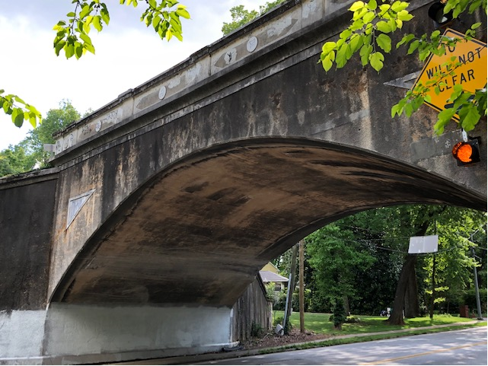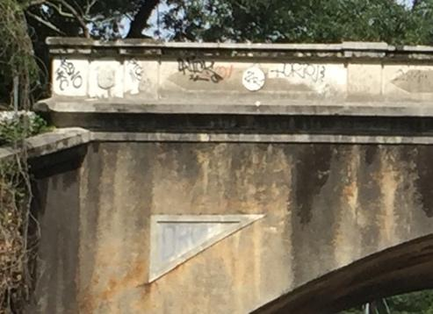
This photo shows the current sorry state of our bridge, an excellent example of a reinforced concrete arch bridge.

